Machine Learning Engineer Nanodegree

Handwritten Arabic character recognition
Tarek M. Sayed
April 17th, 2018

I. Definition

1.1 Project Overview
Optical character recognition (OCR) is the mechanical or electronic conversion of images of typed, handwritten or printed text into machine-encoded text, whether from a scanned document, a photo of a document, a scene-photo (for example the text on signs and billboards in a landscape photo) or from subtitle text superimposed on an image (for example from a television broadcast). It is widely used as a form of information entry from printed paper data records, whether passport documents, invoices, bank statements, computerized receipts, business cards, mail, printouts of static-data, or any suitable documentation. It is a common method of digitizing printed texts so that they can be electronically edited, searched, stored more compactly, displayed on-line, and used in machine processes such as cognitive computing, machine translation, (extracted) text-to-speech, key data and text mining.
OCR is a field of research in pattern recognition, artificial intelligence and computer vision.
The field of optical character recognition (OCR) is very important, especially for offline handwritten recognition systems. Offline handwritten recognition systems are different from online handwritten recognition systems. The ability to deal with large amounts of script data in certain contexts will be invaluable. One example of these applications is the automation of the text transcription process applied on ancient documents considering the complex and irregular nature of writing. Arabic optical text recognition is experiencing slow development compared to other languages.
Handwritten Arabic character recognition (HACR) has attracted considerable attention in recent decades. Researchers have made significant breakthroughs in this field with the rapid development of deep learning algorithms.[1] [2] Arabic is a kind of the Semitic language used in countries of the Middle East as a mother language of millions people.
Arabic handwriting fonts is an ancient art, and there are a lot of old books and scripts need to digitize. That motivate researchers to build algorithms for this job to save ancient Arabic culture.
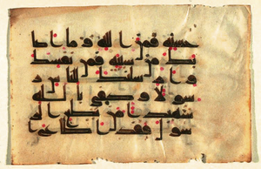
The image shows an old Arabic script.

1.2 Problem Statement
Generally, the Arabic alphabet characters consist of twenty-eight alphabet characters that illustrated in the following table:
ص | ش | س | ز | ر | ذ | د | خ | ح | ج | ث | ت | ب | أ
sad | sheen | seen | zay | raa | thal | dal | khaa | haa | geem | thaa | taa | baa | alef
ي | و | هـ | ن | م | ل | ك | ق | ف | غ | ع | ظ | ط | ض
yaa | waw | haa | noon | meem | lam | kaf | qaf | faa | ghain | ain | zaa | ttaa | dad

There is also a big variety of Arabic handwriting fonts Arabs still use for now. Most of educated Arab people write two fonts Naskh and Reqaa and some times by mistake and fast writing they write a mix of both.
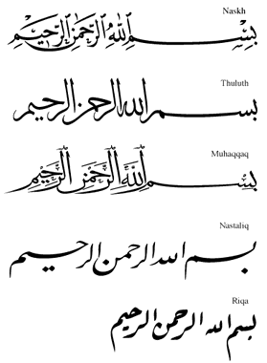
The image shows the same Arabic sentence written in different fonts
Also Some characters are very confusable with similar character stroke that shown in following table:
Master Stroke | ب | ح | د | ر | س | ص | ط | ع | ف | ل
Similar Characters | ب,ت,ث | ج,ح,خ | د,ذ | ر,ز | س,ش | ص,ض | ط,ظ | ع,غ | ف,ق | ل,ك

The tiny distinction of stroke structure bring challenges for some similar character pairs, such as sad and dad. The difference of sad and dad is the dot that above character dad.

1.2.1 Datasets and Inputs
- We will use Arabic Handwritten Characters Dataset from Kaggle you can find it here.
- The dataset is composed of 16,800 characters written by 60 participants, the age range is between 19 to 40 years, and 90% of participants are right-hand. Each participant wrote each character (from ’alef’ to ’yaa’) ten times.
- The database is partitioned into two sets: a training set (13,440 characters to 480 images per class) and a test set (3,360 characters to 120 images per class).
- Writers of training set and test set are exclusive.
- Ordering of including writers to test set are randomized to make sure that writers of test set are not from a single institution (to ensure variability of the test set).

1.2.2 Solution Statement
It is clear from dataset description and the problem statement we have a labeled data with 28 classes (Arabic alphabet letters). So we intend to build Handwritten Arabic character recognition system using Classification algorithms and Deep Learning to recognize an Arabic letter from image.

1.3 Metrics
According to dataset description test set is randomized, shuffled and has a good variability. So we will use accuracy score on test set to evaluate the classifier.
- Accuracy Score is a suitable metric for this dataset because the test set is balanced
(3,360 characters to 120 images per class). So no need for more complex metrics.
- The accuracy score function provided by sklearn.metrics.accuracy_score .
- The accuracy_score function computes the accuracy, either the fraction (default) or the count (normalize=False) of correct predictions.
- In multi-label classification, the function returns the subset accuracy. If the entire set of predicted labels for a sample strictly match with the true set of labels, then the subset accuracy is 1.0; otherwise it is 0.0.
- If is the predicted value of the -th sample and is the corresponding true value, then the fraction of correct predictions over is defined as:
where is the indicator function.
- For MLP and CNN we will use the same function provided in Keras model API evaluate which Returns the loss value & metrics (accuracy) values for the model in test mode.

II. Analysis

2.1 Data Exploration
The datasets provided as 4 CSV files:
- Train Images : "csvTrainImages 13440x1024.csv"
13440 Images every image 1024 pixels in gray scale with Max. = 255 and Min. = 0
- Train labels : "csvTrainLabel 13440x1.csv"
13440 label between 1 and 28 represent Arabic alphabet letters.
- Test Images : "csvTestImages 3360x1024.csv"
3360 Images every image 1024 pixels in gray scale with Max. = 255 and Min. = 0
- Test labels : "csvTestLabel 3360x1.csv"
3360 label between 1 and 28 represent Arabic alphabet letters.

2.2 Exploratory Visualization
We show random 20 images from Train images after reshaping them to 32 x 32 pixels with showing the letter related to image label in as Arabic letter and how it’s sound using English letters.
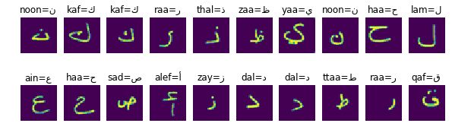
Showing an image of them in detail to show the value for each pixel.
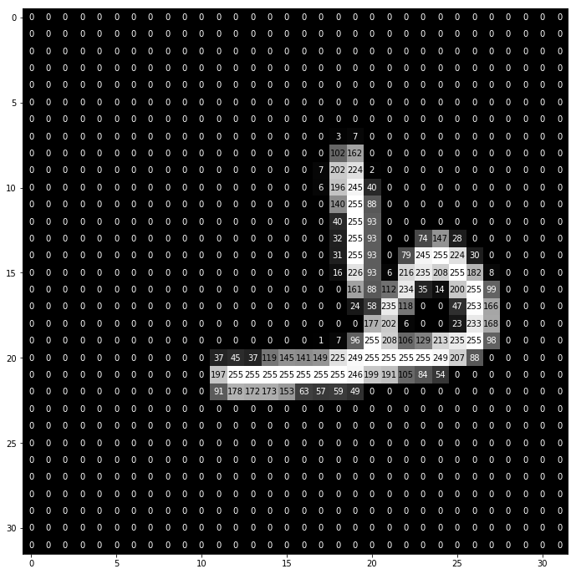
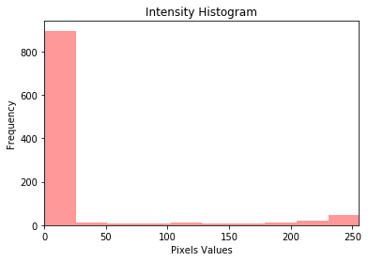
Show the image Intensity Histogram:

2.3 Algorithms and Techniques
The project separated to two parts :
- The first part using classic classifiers : Support Vector Machines (SVM), Ensemble Methods (Random Forest, AdaBoost and Decision tree).
- The second part using Deep Learning: MLP and CNN.

2.3.1 Part1:
In this part we discuss the strengths and weaknesses for each algorithm in first part:
- Support Vector Machines (SVM):
- SVM constructs a hyperplane or set of hyperplanes in a high- or infinite-dimensional space, which can be used for classification, regression, or other tasks like outliers detection. Intuitively, a good separation is achieved by the hyperplane that has the largest distance to the nearest training-data point of any class (so-called functional margin), since in general the larger the margin the lower the generalization error of the classifier.
- The intuition of SVM:
tries to maximize the margin between the hyperplane and the samples. Thanks to that, the decisions it makes, are more accurate. Large distance between the decision boundary and the samples, makes the probability of miss classifying lower. This kind of classifiers are called large margin classifiers.
- Strengths of SVM: can model non-linear decision boundaries with wide margin, and there are many kernels to choose from. They are also fairly robust against overfitting, especially in high-dimensional space.
- Weaknesses : memory intensive, trickier to tune due to the importance of picking the right kernel, and don't scale well to larger datasets.
- The algorithm provided in sklearn.svm.SVC
- Random Forest Classifier:
- Random forests or random decision forests are an ensemble learning method for classification, regression and other tasks, that operate by constructing a multitude of decision trees (will discuss below) at training time and outputting the class that is the mode of the classes (classification) or mean prediction (regression) of the individual trees. Random decision forests correct for decision trees' habit of overfitting to their training set
- Strengths: The model is easy to use. It can very easily handle categorical variables that do not expect linear features or even features that interact linearly. The model also handles high dimensional spaces very well, as well as large numbers of training examples. Finally, it's less likely to overfit than a decision tree.
- Weaknesses : it's more difficult to interpret a Random Forest than a Decision Tree.
- The algorithm provided in sklearn.ensemble.RandomForestClassifier
- Adaboost:
- AdaBoost or Adaptive Boosting is a type of "Ensemble Learning" where multiple learners are employed to build a stronger learning algorithm. AdaBoost works by choosing a base algorithm (e.g. decision trees) and iteratively improving it by accounting for the incorrectly classified examples in the training set.
- We assign equal weights to all the training examples and choose a base algorithm. At each step of iteration, we apply the base algorithm to the training set and increase the weights of the incorrectly classified examples. We iterate n times, each time applying base learner on the training set with updated weights. The final model is the weighted sum of the n learners.
- Strengths of Adaboost is a powerful classification algorithm that tends to be very adaptive. It can capture very complex decision boundaries. Another advantage, it doesn't require to tweak lot of parameters.
- Weaknesses : sensitive to noisy data and outliers. It can also be slow to train.
- The algorithm provided in sklearn.ensemble.AdaBoostClassifier
- Decision Trees :
- Decision tree learning uses a decision tree to go from observations about an item (represented in the branches) to conclusions about the item's target value (represented in the leaves).
- Tree models where the target variable can take a discrete set of values are called classification trees; in these tree structures, leaves represent class labels and branches represent conjunctions of features that lead to those class labels.
- Decision Tree Classifier breaks down a dataset into smaller and smaller subsets while at the same time an associated decision tree is incrementally developed. The final result is a tree with decision nodes and leaf nodes. The topmost decision node in a tree which corresponds to the best predictor called root node.
- Strengths : perform very well in practice. They are robust to outliers, scalable, and able to naturally model non-linear decision boundaries .
- Weaknesses : if a complex model is used as the base classifier, this can lead to overfitting.
- The algorithm provided in sklearn.tree.DecisionTreeClassifier
- From previous details it is clear that all four algorithms suitable to work on our data. But using dimensionality reduction will be very useful to increase algorithms speed and performance So we will use PCA as a preprocessing step.
- Also to tune the hyper-parameters for the algorithms we will run Grid Search algorithm.

2.3.2 Part two:
In this part we will discuss Deep Learning techniques which are very promised in computer vision field:
- Deep Neural networks consist of input layer and multiple nonlinear hidden layers and output layer, so the number of connections and trainable parameters are very large.
- The deep neural network needs very large set of examples to prevent over fitting.
- One class type of Deep Neural Network with comparatively smaller set of parameters and easier to train is Convolution Neural Network (CNN).
- CNN is a multi-layer feed-forward neural network that extract features and properties from the input data (images or sounds). CNN trained with neural network back-propagation algorithm.
- CNN have the ability to learn from high-dimensional complex inputs, nonlinear mappings from very large number of data (images or sounds).
- The advantage of CNN is that it automatically extracts the salient features which are invariant and a certain degree to shift and shape distortions of the input characters. Another major advantage of CNN is the use of shared weight in convolution layers, which means that the same filter is used for each input in the layer. The share weight reduces parameter number and improves performance.
- Pooling Layer It is common to periodically insert a Pooling layer in-between successive Convolution layers in a CNN architecture. Its function is to progressively reduce the spatial size of the representation to reduce the amount of parameters and computation in the network, and hence to also control overfitting. The Pooling Layer operates independently on every depth slice of the input and resizes it spatially, using the MAX operation. The most common form is a pooling layer with filters of size 2x2 applied with a stride of 2 down samples every depth slice in the input by 2 along both width and height, discarding 75% of the activations. Every MAX operation would in this case be taking a max over 4 numbers (little 2x2 region in some depth slice). The depth dimension remains unchanged.

Image show Max Pooling operation
- Deep Neural Networks will be implemented using Keras The Python Deep Learning library.

2.4 Benchmark
- As mentioned in Metrics we will use accuracy score on test set to evaluate the algorithms.
- The dataset is based on research paper which achieved 94.9% accuracy which also mentioned some related work achieved accuracy 77.25%, 93.92%, 73.4%, 93.8%, 93.3% and 90.73%.
- So we well choose the lowest accuracy mentioned in this paper 73.4% as a benchmark.

III. Methodology

3.1 Data Preprocessing
As mentioned in Data Exploration the images are in gray scale with pixels value between 0-255.
We have proceed preprocessing steps to improve quality of the algorithms:
- Data scaling: Dividing every pixel value by 255.0 to change the range between 0-1.
- Data Normalization: to set values with zero mean.
- Dimensionality Reduction: using Principal component analysis (PCA) to improve classic algorithms speed and quality.(This step will skipped with Deep Learning ).
- Encode categorical integer labels using a One-Hot Encoding to work with with output layer of Neural Networks.
- Reshape Input Data from 1024 to 23 x 32 to work with NN input.

3.2 Implementation
All python libraries used in the implementation of the algorithms mentioned in Algorithms and Techniques with links to libraries documentation.

3.2.1 The Classic Algorithms:
We Used grid Search for each algorithm and used the best estimator found by grid search as algorithm model, the hyper-parameters tuned for algorithms are:
- SVM : C Penalty parameter and Gamma Kernel coefficient for rbf.
hyper-parameter | Range
C | 1e3, 5e3, 1e4, 5e4, 1e5
Gamma | 0.0001, 0.0005, 0.001, 0.005, 0.01, 0.1
Grid search takes much time but the results was great.
- Random Forest: n_estimators number of estimators, max_depth Trees maximum depth.
hyper-parameter | Range
n_estimators | From 10 to 40 with step 2
max_depth | From 3 to 30 with step 1
Grid search takes a little bit much time but less than SVM also accuracy was less.
- AdaBoost: n_estimators number of estimators.
hyper-parameter | Range
n_estimators | From 10 to 40 with step 2
- Decision Tree: max_depth Trees maximum depth.
hyper-parameter | Range
max_depth | From 3 to 30 with step 1

3.2.2 Get Accuracy Function:
- get_accuracy function accept 5 attributes Classifier, Training features, Training labels, Testing features, Testing labels.
- The function fits the classifier on training data, predict labels for testing data and print accuracy score for testing data as percent value and return it.

3.2.3 Deep Learning:
In this part we build two deep neural networks MLP and CNN:

MLP Architecture:
- Input layer followed with flatten layer to set image pixels as a row.
- Two hidden layers the first one with 128 node and the second with 64 node.
- Every layer of the hidden layers with Relu activation function and followed by drop out layer to prevent overfitting.
- Output layer with softmax activation function with 28 output class.

CNN Architecture:
23x32
Image
Flatten layer
Relu
128 nodes
64 nodes
Relu
softmax
28 classes
Output layer
- Input layer is a convolution layer with 128 filters with kernel size = 3 and valid padding with Relu activation function.
- The second convolution layer with 64 filters with kernel size = 3 and same padding with Relu activation function.
- Every convolution layer followed by Max Pooling layer and Batch Normalization.
- The first convolution layer followed by drop out layer to prevent overfitting which may caused by complexity of many filters.
- Fully connected layers we used the same architecture as in the previous MLP network.

3.3 Refinement
32x32
Image
Flatten layer
Relu
128 nodes
64 nodes
Relu
softmax
28 classes
Output layer
Relu
Conv.
128 filters
Conv.
64 filters
Relu
Pool size=2
PL
Pool size=2
PL
- For classic algorithms using grid search give a good results but only SVM gives accuracy more than the benchmark with 74% accuracy.
- For Deep learning we use many trials of architectures to get a good results and CNN model got accuracy more than the benchmark with 86% accuracy.
- Adding Batch Normalization improved CNN accuracy from 78% to 82%.
- Changing Dropout ratio from 0.2 to 0.5 improved the accuracy for 86%.

IV. Results

Model Evaluation and Validation
To evaluate the model:
we choose a random 6 images from test set to predict their labels and the model predicted 4 labels correctly.
Another step we create 6 character images using paint and the model predicted 3 labels correctly.
- As a result for all trials and testing the CNN model shows the best accuracy with 86.4% even we use a simple architecture.
- The model passed the benchmark metric.
- The model could predict 50% of very unseen data correctly.
- The model is robust enough as personal project but it can be improved to work as a real world application.

V. Conclusion

5.1 Free-Form Visualization
To show the model quality we get the images classified incorrectly in test set and result shows the model confused mostly in letters which have the same letter stroke as we mentioned in Problem Statement, That may confuse a human if Arabic is not his native language. The result shows in the following table:
True Label | Predicted Label | True Letter | Predicted letter
Jeem | Haa | ج | ح
Khaa | Haa | خ | ح
Dal | Thal | د | ذ
Raa | Zay | ر | ز
Ttaa | Zaa | ط | ظ
Noon | Lam | ل | ن
Thal | Zay | ذ | ز
Ain | Khaa | ع | خ
Thaa | Taa | ث | ت
Faa | Qaf | ف | ق
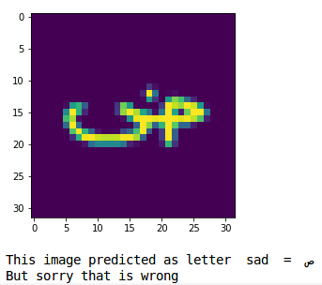
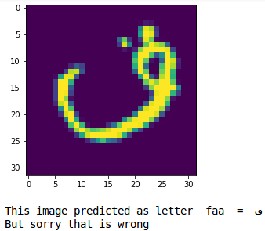
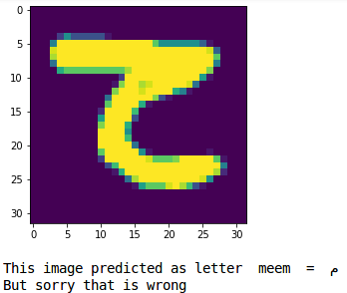

Also the following histogram show letters frequently predicted wrong:
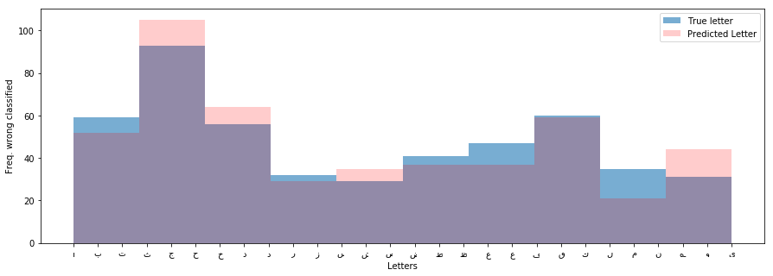

5.2 Reflection
Through working on this project we got some of important points to focus:
- Data Exploration and Data Visualization are very important steps to start with, That you should to the sea before you dive in.
- Preprocessing data is an important step to improve the model speed and quality.
- Classic ML Algorithms need Dimensionality Reduction to speed up and get reasonable accuracy But still not very suitable for image classification.
- The Deep Convolution Neural Networks are very promised in Computer Vision and Handwritten Arabic OCR fields. Also Support Vector Machines algorithm can used in this fields as a cheaper solution with reasonable accuracy.
- Deep Learning is often more art than science and there a lot of tips to deal with network training issues.

5.3 Improvement
- The CNN model can be improved using the power of GPUs (I don’t have) by using augmentation, regularization and transfer learning.
- Also I think using Tensorflow may improve the results for CNN model because it gives more complicated options.

